**Our Safeguarding Team**

If you have any concerns regarding safeguarding or child protection, please speak to a member of our team.

Hannah Rogers

Principal

Senior Designated Safeguard Lead

Responsible for Child Sexual Exploitation (CSE)

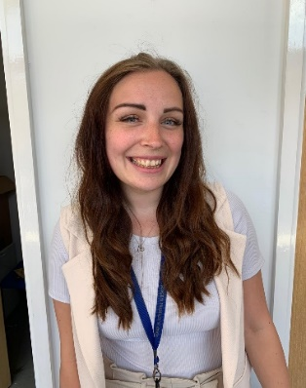

Danny Webb

Breakfast and Afterschool Club Manager

Designated Safeguarding Lead

Natasha McDowell

Early Years Lead

Designated Safeguard Lead