Dear all,
With the new school term underway, I wanted to provide you with an update on our plans to return to Buckton next month.

I am delighted to be able to confirm that the school is now on site and in position.

This means that we remain on track for our handover date of February 16th.

I will update you again on progress later this month, but getting all forty-three building modules on site and into position was the key milestone towards reopening in our community.

As we look towards moving back to Buckton, I wanted to share with you two further dates:

Firstly, and most importantly, we plan to reopen school after half-term on Tuesday 27th February.

During the holiday, we need to decant all our equipment, furniture and resources from Pineham and the current school at Buckton, as well as set up our new school – hence that extra day on Monday 26th of February is required to have everything ready for our children.

Secondly, I would like to invite you a meeting on Thursday 8th February @ 7pm at Pineham Barns to brief you about our return to school in Buckton. I will of course provide a detailed update about this for those of you who are unable to attend.

Mrs Straiton will also be in touch next month about an opportunity for you to all to visit the school.

Finally, I am delighted to share the news that work has now begun on the delivery and rebuild of our original school. Presently, we are working through the designs for the school and I can share that the school will be a traditional brick build structure with a much more sustainable design; incorporating plans for solar panels and a green roof.

The timelines for this project remain unchanged with the rebuilt school due to reopen no later than September 2026. In my February update, I will provide a full project timeline.

As ever, can I thank you for your ongoing support, we are now not very far away from being back in Buckton!

Yours sincerely

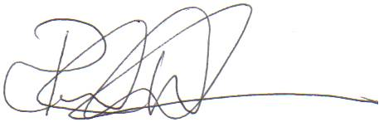

Paul Watson
Chief Executive
Preston Hedges Trust

